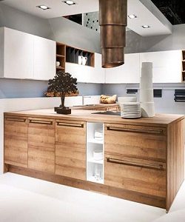

Rosewood kitchen cabinet

$203.85

Availability: In stock

Description

Modern wood kitchen island with cabinets. Wood cabinets made with high quality wood solids, certified for the highest quality. Soft close hinges, drawer boxes and lifting mechanisms.